Talks of Note: Musical Reflections.
A journey across genres presented by the ANU Community Music Centre

This dynamic and engaging series of lectures spaced throughout each year will feature a variety of informative and interesting talks on different musical genres, with representation of various musical styles, composers and topics. Audiences will be encouraged to engage in lively discussions with the presenters and other audience members.

Tuesdays
10:30 arrival, cup of tea/coffee
11am - 12pm talk
12:30 - 1:15 members can stay for free lunchtime concert

LECTURE ONE 26 March
Tobias Cole

A birthday celebration of Handel’s most famous opera.

This year marks the 300th anniversary since Handel’s opera Julius Caesar premiered in London. Tobias Cole (countertenor, conductor, director of Handel in the Theatre and host of Cole’s Opera Salon) will discuss the opera, its context, perform key excerpts, and reflect on its impact over the subsequent 300 years.

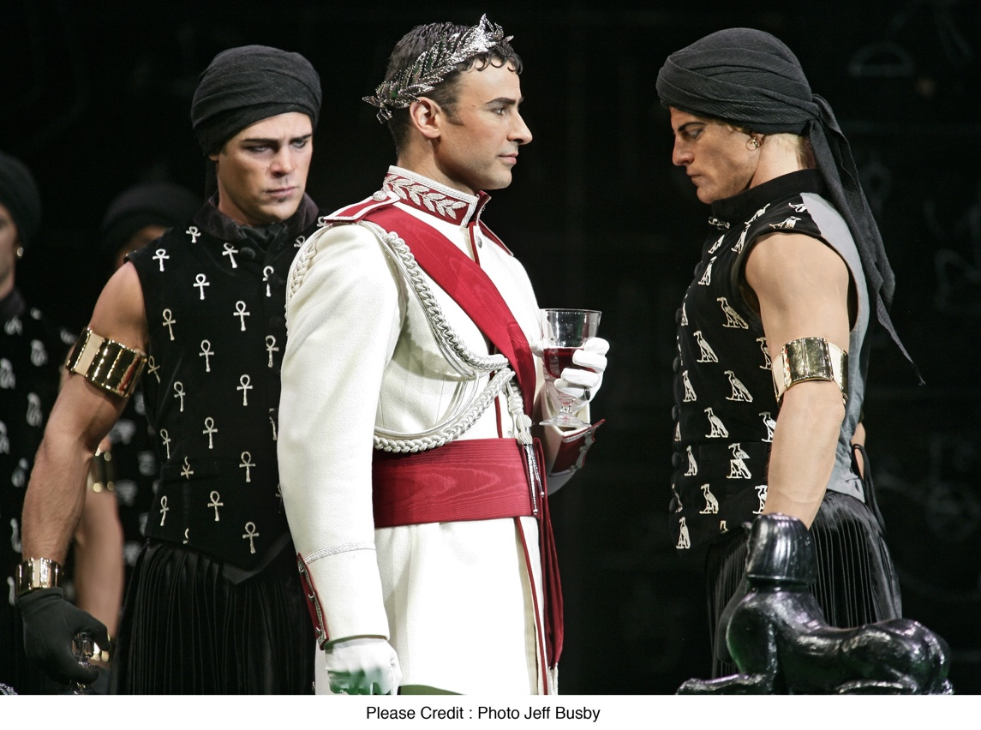
Photo by Jeff Busby from the Opera Australia production of Giulio Cesare 2006, Tobias Cole as Cesare.

LECTURE TWO 23 April
Leisa Keen

Sarah, Ella & Me

Leisa Keen compares the music of Sarah Vaughan and Ella Fitzgerald; and how a contemporary jazz singer can inject inspiration from the greats into their own performing. Leisa delves into the careers of two of the jazz giants, through entertaining stories and songs and some exploration into their improvising styles and techniques.

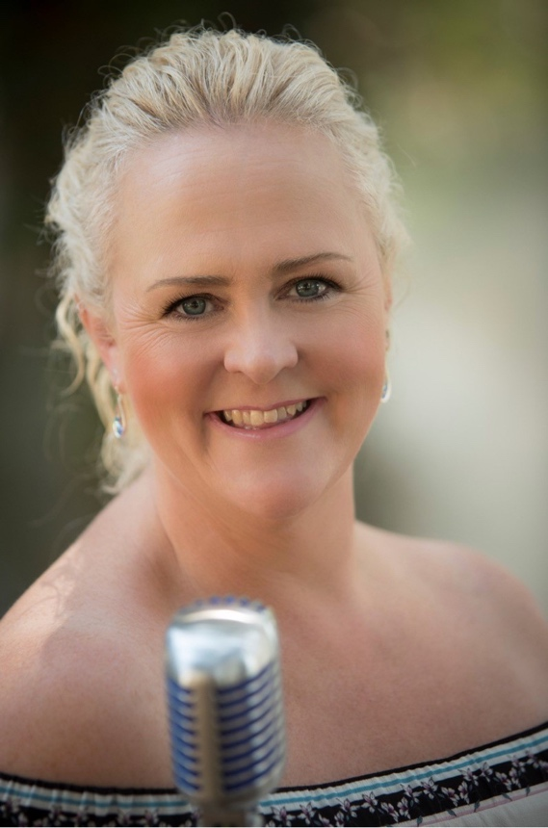

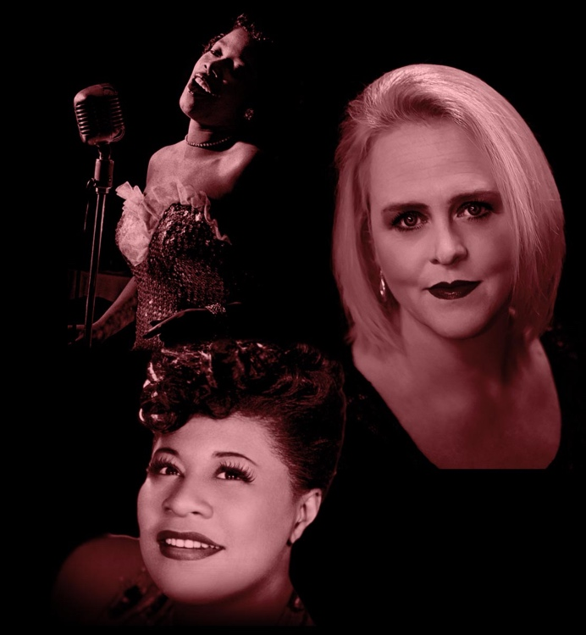

LECTURE THREE 21 May
Sarah Mann

Singing. Unplugged.
PhD Candidate Sarah Mann (soprano) explores Western operatic singing perception.
Why do we experience intense emotions listening to Western operatic singing? What is it about the acoustics of a soprano’s operatic technique that modifies our attention? Vocal sound is affected by emotion and conveys information useful for survival. These 'signals' are processed quickly and efficiently by our auditory system, enabling fast responses. How might operatic technique contain and control such signals? Are they a clue to the chills, tears and gasps opera audiences experience? Sarah has spent the last 3 years finding out! Join her as she summarises and demonstrates her research.
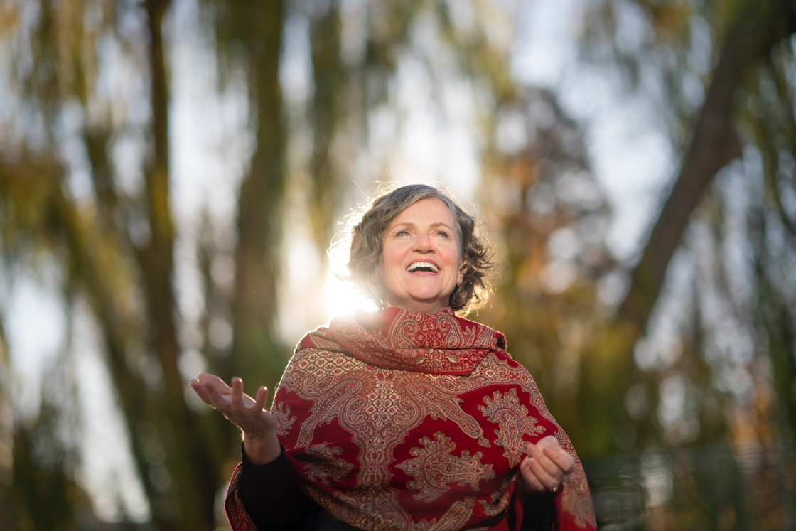

LECTURE FOUR 4 June
Aperion Baroque
John Ma and Marie Searles

Revisiting musical assumptions in Baroque and Classical music.

The field of Early Music (historical performance practice) is much more than playing old music on old instruments! In the 300 years since the Baroque era, there have been vast changes in society, language, and aesthetics; and Early Music is an attempt to rediscover the contemporary ideas, context, and techniques in order to better understand how to interpret the "blobs on the page". In this presentation, Apeiron Baroque will give a general overview of some of these concepts, and the way that we employ them in our interpretations of music from the past.

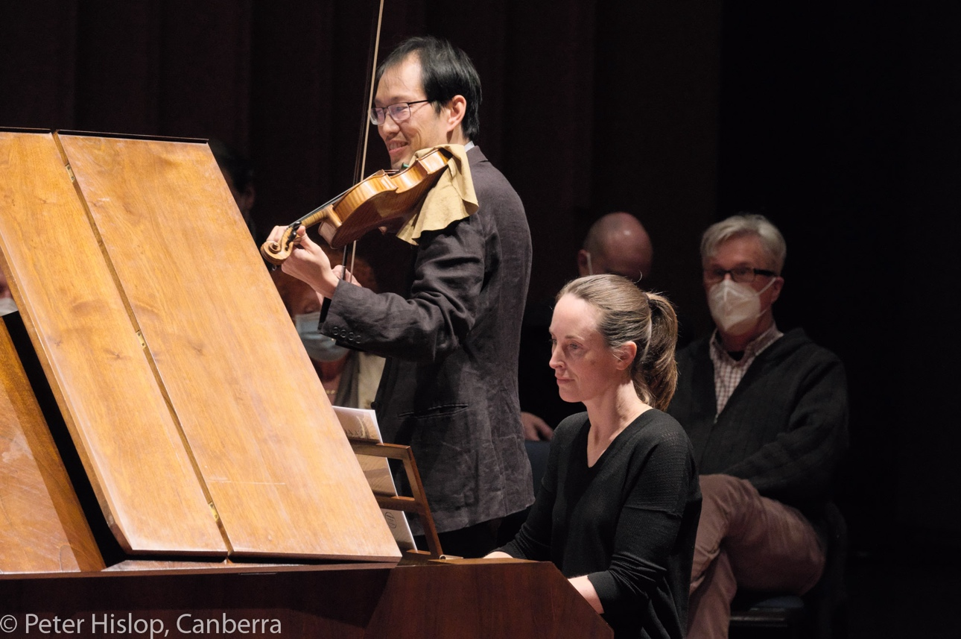

Photo credit: Peter Hislop

